**Linux User Expiry**

A developer kirsty has been assigned Nautilus project temporarily as a backup resource. As a temporary resource for this project, we need a temporary user for kirsty. It’s a good idea to create a user with a set expiration date so that the user won't be able to access servers beyond that point.

Therefore, create a user named kirsty on the App Server 2. Set expiry date to 2021-03-28 in Stratos Datacenter. Make sure the user is created as per standard and is in lowercase.



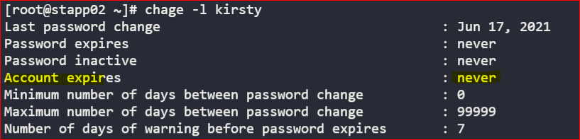





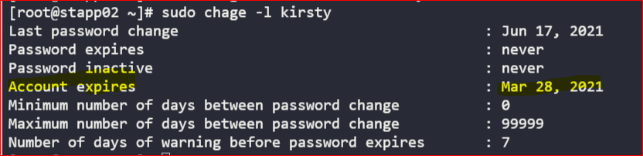

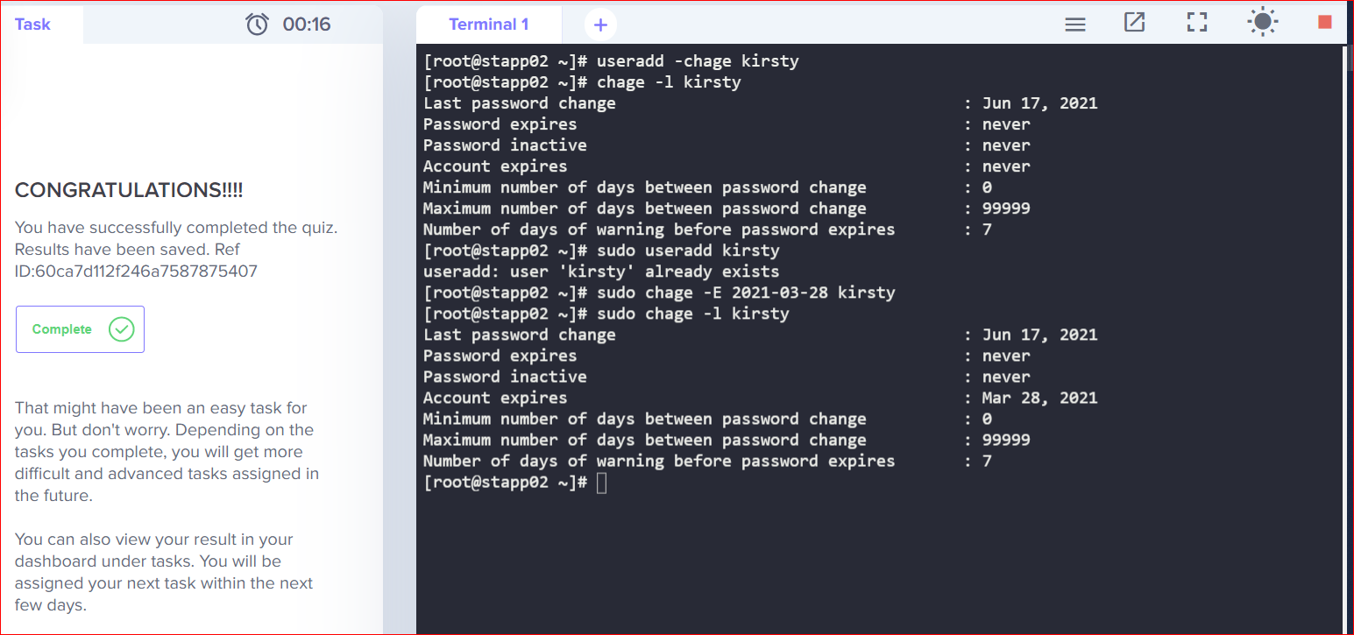

https://www.tecmint.com/add-users-in-linux/